**POSTMAN API CRUD OPERATIONS**

**STEP1:** Download postman and select windows 64 bit

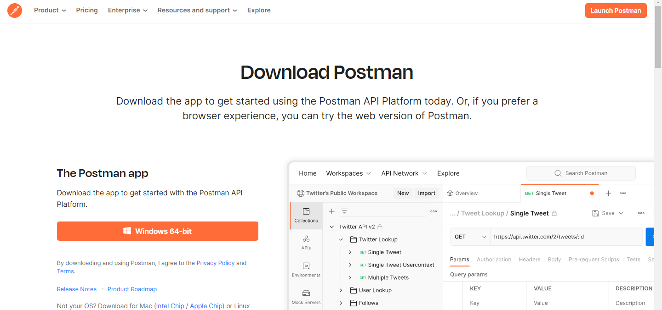

**STEP2:** Accept the agreements and install

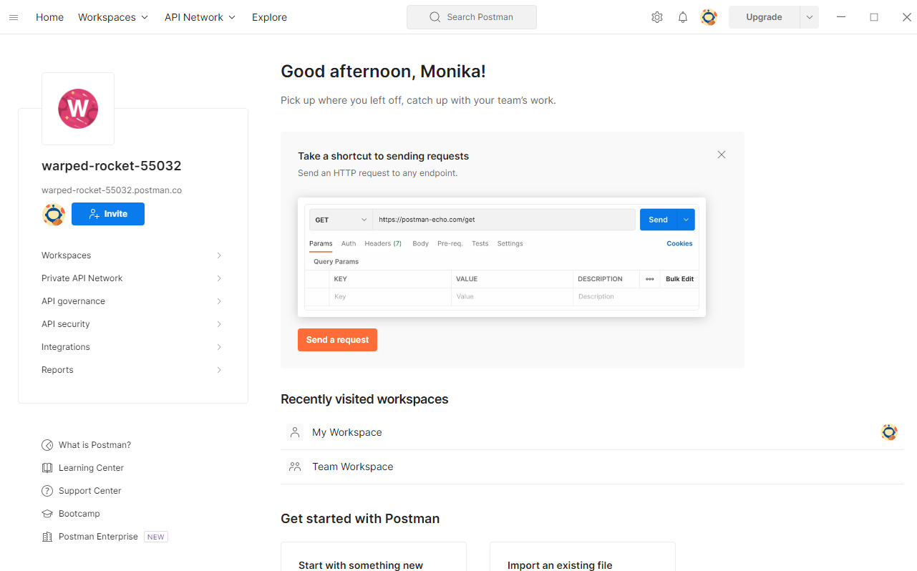

**STEP 3:**  Go to workspace.

**CREATING AN API**

* Click on + symbol to create a new API

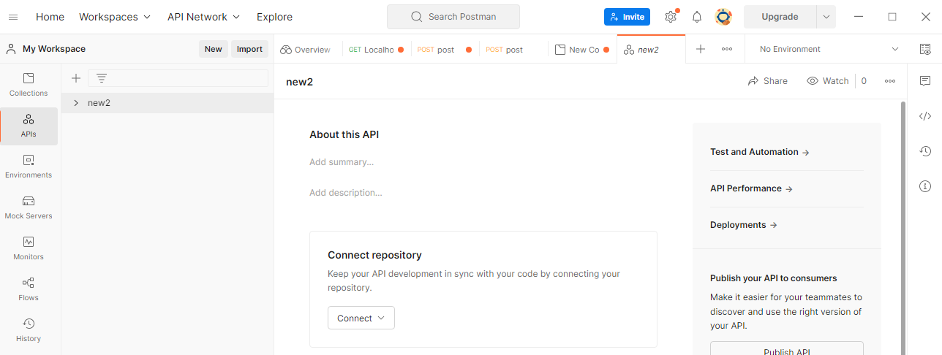

**UPDATING AN API**

* Select the created API and right click on it and select rename option

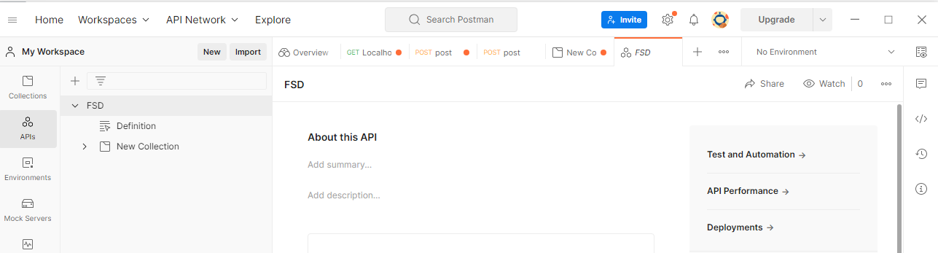

**DELETING AN API**

* Select the created API and right click on it and select the delete option

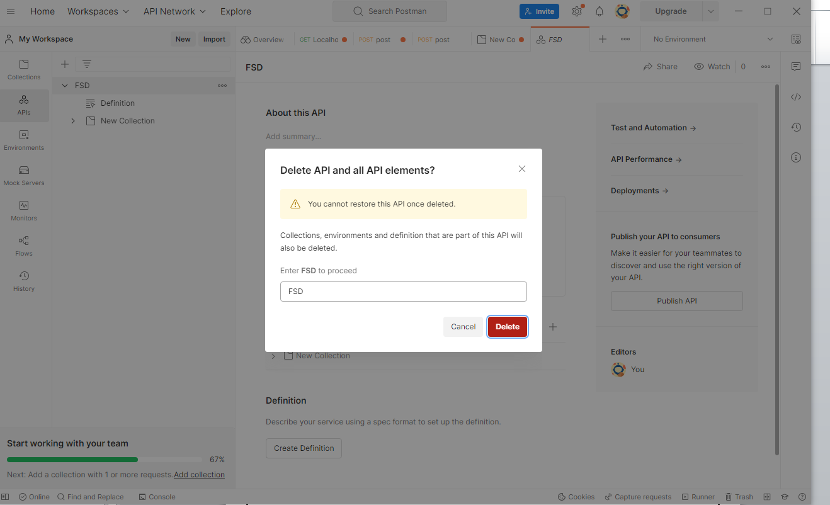

**STEP4: Creating a new collection**

* Select the created API and right click on it and select the add collection to create new collection.

